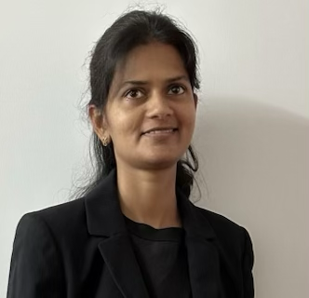

**Rosey Carolin**

Shanghai, China

+8613761132273

Skype id: rosey.carolin

rosey_carolin@yahoo.com

WeChat id: RoseyCarolin

**Summary**

Experienced and passionate Teacher with a love for educating today’s young learner’s, with proven ability to engage children in conversation to determine their specific interests and limitations. Flexible and friendly teacher equipped with the knowledge that learning a language takes time and practice. Interacting with children, ensuring their physical and emotional well-being at all times.

**Work Experience**

**English Trainer- Haiple English Training Centre-Shanghai Mar - Dec 2023**

·      Teaching English for students by maintaining positive student-teacher relationship and communicate with parents on a daily basis.

·      Teaching and training English for adult Chinese faculty members focusing on pronunciation and communication skills.

·      Plan and deliver English language lessons that incorporate the use of audio-visual aids and various English teaching methods.

* Teaching English for Young learners by keeping students on-task with pro-active behaviour and positive reinforcement strategies.

·      Attend faculty meetings and discuss programs to help motivate students to use the English language properly.

* Created and implemented lesson plans focused on improving overall English proficiency.

**Volunteer English Teacher- Foreigners Christian Community- Shanghai Jan 2017-Dec 2019**

* Helping students improve their listening, speaking, reading and writing skills via individual and group sessions.
* Direct and educate children regarding hygiene and safety.
* Implemented multiple musical and art-related activities that improved student’s creative skills.
* Designed activities to be both fun and educational for students.

·      Proficient in maintaining complete and accurate records of assigned children, placing a special focus on confidentiality.

**Megastar Survey and Consultants-India Jan 2012-Apr 2014**

* Conduct meeting and classes in teaching English vocabulary and pronunciation with team members.

·      Collaborated closely with team members as well as clients to identify needs and propose solutions.

·      Implementing effective communication strategies to build customer loyalty and customer satisfaction.

·      Finding creative solutions to work and meet deadlines.

·      Forming connections to enhance relationships professionally.

**Technical Assistant & Lecturer-Mar Gregorios College-India Jan 2010-Jan 2011**

·      Planning, preparing and delivering lessons to a high standard.

·      Performed a variety of administrative duties and curriculum planning.

·      Marking students course work.

·      Conduct classes in disciplined environment and provide high quality learning experience for students.

·      Participating in meetings with teachers and parents.

* Provide feedback to students based on observed behaviours and completed work.

**Certification**

·      **TEFL**- Teaching English as Foreign bLanguage (120 hours)

·      Specialization course in Young Learners

**Education**

**Master's in Computer Application**2006-2009 Anna University-India

**Bachelor's in Physics** 2003-2006 Madras University-India

**Language Skills**

Japanese – Conversation level

Chinese – Basic level

English – Native level

**Classroom and Online teaching video link**

<https://drive.google.com/file/d/1wrC_PbCcjApEZEciQKY7vU6DnSYr2XTK/view?usp=drivesdk>

<https://drive.google.com/file/d/1KVm8EKSjR9yF7cgO_m2EbMgJSFxmFzQR/view?usp=drivesdk>