RESUME

AJITA VIJAYKUMAR

Contact No : 8105692441/8660813690 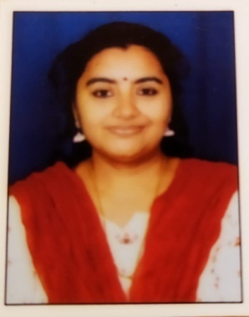

# Email Id : ajitavijay75@gmail.com

NAME : AJITA VIJAYKUMAR

MAIDEN NAME : U.P.AJITA

FATHER’S NAME : Late MR. U.P.VENUGOPAL

DATE OF BIRTH : 01-07-1975

NATIONALITY : INDIAN

ADDRESS : MRS. AJITA VIJAYKUMAR

CHURCH ROAD

AMADALLI, KARWAR

MARITAL STATUS : MARRIED

# HUSBAND NAME : K. VIJAYKUMAR

LANGUAGES KNOWN : MALAYALAM, ENGLISH, HINDI, KANNADA,

ORIYA & KONKANI.

EDUCATIONAL QUALIFICATION : B.A COURSE

: B.ED

: NTT(Nursery Teachers Training)

: DIPLOMA IN COMPUTER

: TEFL/TESOL QUALIFIED

: TRAINED IN PHONICS

TEACHER TRAINING COURSE

WORK EXPERIENCE :

* Served as PRT teacher with Kendriya Vidyalaya Karwar

From: March 2011 to August 2011

* Served as PRT with Navy Children School ,Karwar

From : April 2012 to March2013

* Served as PRT with Jaycee School ,Hattikeri

From : April 2013 to March2014

* Served as TGT with Navy Children School ,Karwar

From : April 2014 to May2022

STRENGTH :

* Good communication skill
* Ability to work in a team.
* Time management capability.
* English Teaching for Classes 1-10
* Hosting Events
* Working as Magazine Editor

Declaration:

The details furnished above are genuine to the best of my knowledge. If given an opportunity, I will serve you to the best of my ability.