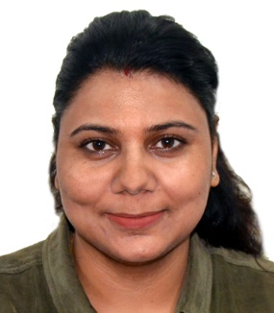

swati sharma

101, J Block Arjun Enclave [ssswatisharma17@gmail.com](mailto:ssswatisharma17@gmail.com)

GMS Road, Dehradun-248001 India +919012949522

# Objective

To education children at the primary/junior level.

# Highlights of Qualifications

* TEFL certification Course from Asian college of Teacher
* Able to speak, read and write in English
* Possess special interest in intramural extra-curricular activities
* Familiar with software commonly found in school such as Microsoft Office

# Education

**Bachelor of Education (Primary/Junior)** 2012 – 2014

HNB Garhwal University, Campus India

**Master of Business Administration – Administration** 2007 – 2009

Uttarakhand Technical University India

**Bachelor Of Commerce** 2004 – 2007

HNB Garhwal University, Campus India

# Classroom Experience

**Santoshi Bal Vidya Mandir School**  March 2019 – December 2023

India

* Planned and delivered math, language and social studies lessons to 20 grade 5 students
* Enhance the “mathematics” problem solving Techniques.
* Introduce different interest creating Stories, Play & Activities for improving English .
* Adjusted lesson plans to respond to the needs of diverse learning styles
* Enhanced the “Heritage” unit by introducing the use of online genealogy resources
* Implemented a reading “show and tell” program for students to present their favorite books
* Organized and created learning stations and bulletin boards

**Himalayan doon academy college**  Jan 2010 – February 2012

India

* Students counseling
* Upgrades students new learning skills
* Academic calendars Planning
* Examination and Inspections Planning

# Interests

Reading, writing, hiking, healthy living